

# Perth Modern School

### Semester Two Examination, 2016

### Question/Answer Booklet

# MATHEMATICS

Student Name: _______________________

Teachers Name: ____________________

If required by your examination administrator, please place your student identification label in this box

**SPECIALIST**

**UNITS 3 AND 4**

## Section One:

## Calculator-free

|  |  |  |  |  |  |  |  |  |
| --- | --- | --- | --- | --- | --- | --- | --- | --- |
| Student Number: In figures |  |  |  |  |  |  |  |  |

In words

## Time allowed for this section

Reading time before commencing work: five minutes

Working time for section: fifty minutes

## Materials required/recommended for this section

***To be provided by the supervisor***

This Question/Answer Booklet

Formula Sheet

***To be provided by the candidate***

Standard items: pens (blue/black preferred), pencils (including coloured), sharpener, correction fluid/tape, eraser, ruler, highlighters

Special items: nil

## Important note to candidates

No other items may be taken into the examination room. It is **your** responsibility to ensure that you do not have any unauthorised notes or other items of a non-personal nature in the examination room. If you have any unauthorised material with you, hand it to the supervisor **before** reading any further.

## Structure of this paper

|  |  |  |  |  |  |
| --- | --- | --- | --- | --- | --- |
| Section | Number of questions available | Number of questions to be answered | Working  time (minutes) | Marks available | Percentage of exam |
| Section One:  Calculator-free | 8 | 8 | 50 | 52 | 35 |
| Section Two:  Calculator-assumed | 12 | 12 | 100 | 97 | 65 |
|  | | | **Total** | 149 | 100 |

## Instructions to candidates

1. The rules for the conduct of examinations are detailed in the school handbook. Sitting this examination implies that you agree to abide by these rules.

2. Write your answers in this Question/Answer Booklet.

3. You must be careful to confine your response to the specific question asked and to follow any instructions that are specified to a particular question.

4. Spare pages are included at the end of this booklet. They can be used for planning your responses and/or as additional space if required to continue an answer.

* Planning: If you use the spare pages for planning, indicate this clearly at the top of the page.
* Continuing an answer: If you need to use the space to continue an answer, indicate in the original answer space where the answer is continued, i.e. give the page number. Fill in the number of the question that you are continuing to answer at the top of the page.

5. **Show** **all your working clearly**. Your working should be in sufficient detail to allow your answers to be checked readily and for marks to be awarded for reasoning. Incorrect answers given without supporting reasoning cannot be allocated any marks. For any question or part question worth more than two marks, valid working or justification is required to receive full marks. If you repeat any question, ensure that you cancel the answer you do not wish to have marked.

6. It is recommended that you **do not use pencil**, except in diagrams.

7. The Formula Sheet is **not** to be handed in with your Question/Booklet.

Section One: Calculator-free 35% (52 Marks)

This section has**eight (****8)** questions. Answer **all** questions. Write your answers in the spaces provided.

Working time for this section is 50 minutes.

Question 1 (14 marks)

(a) Evaluate  (3)

(b) Evaluate  (4)

(c) Determine  (3)

(d) Determine 

HINT: Use partial fractions. (4)

Question 2 (4 marks)

(4 marks)

Solve the complex equation  (4)

Question 3 (5 marks)

(a) Sketch  on the set of axes below. (3)

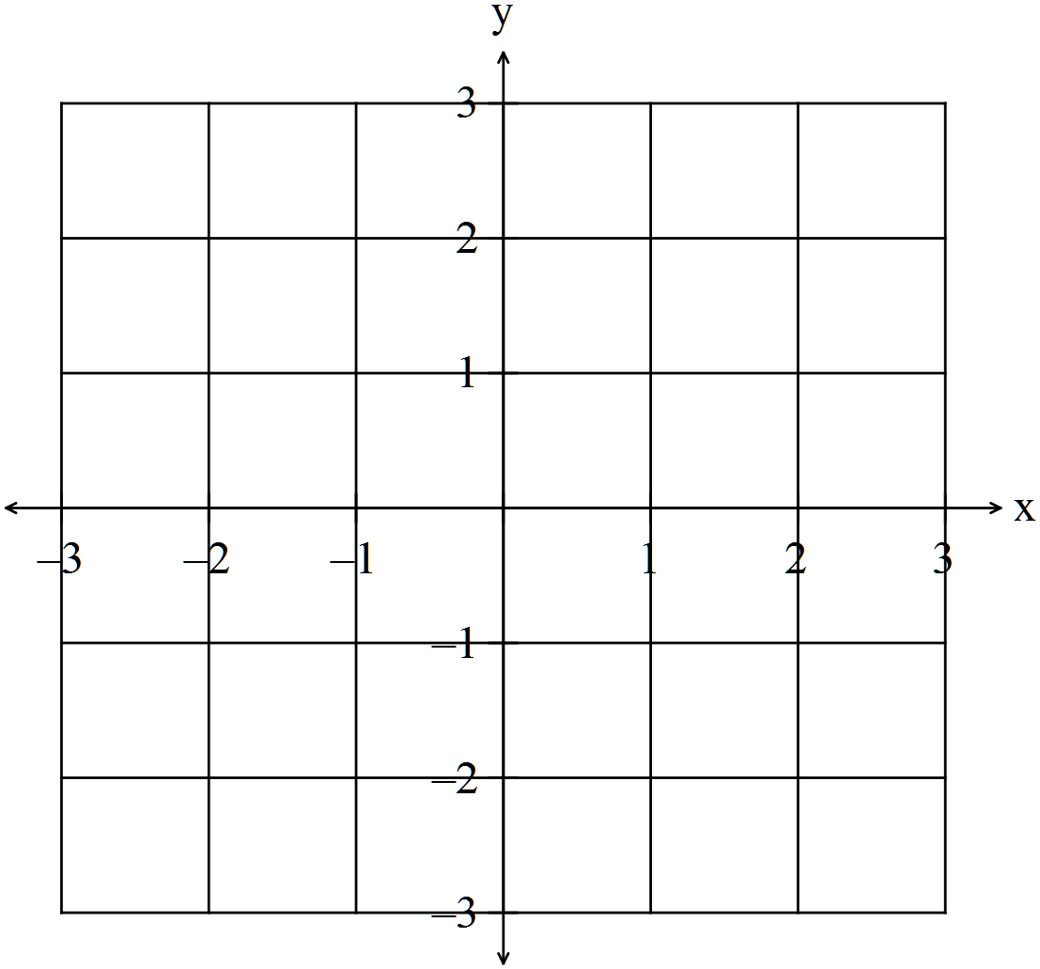

(b) If  find the expression for  (2)

**Question 4 (7 marks)**

(a) Solve the equation  (5)

(b) The function  is sketched on the set of axes below.

Sketch  on the set of axes below. (2)

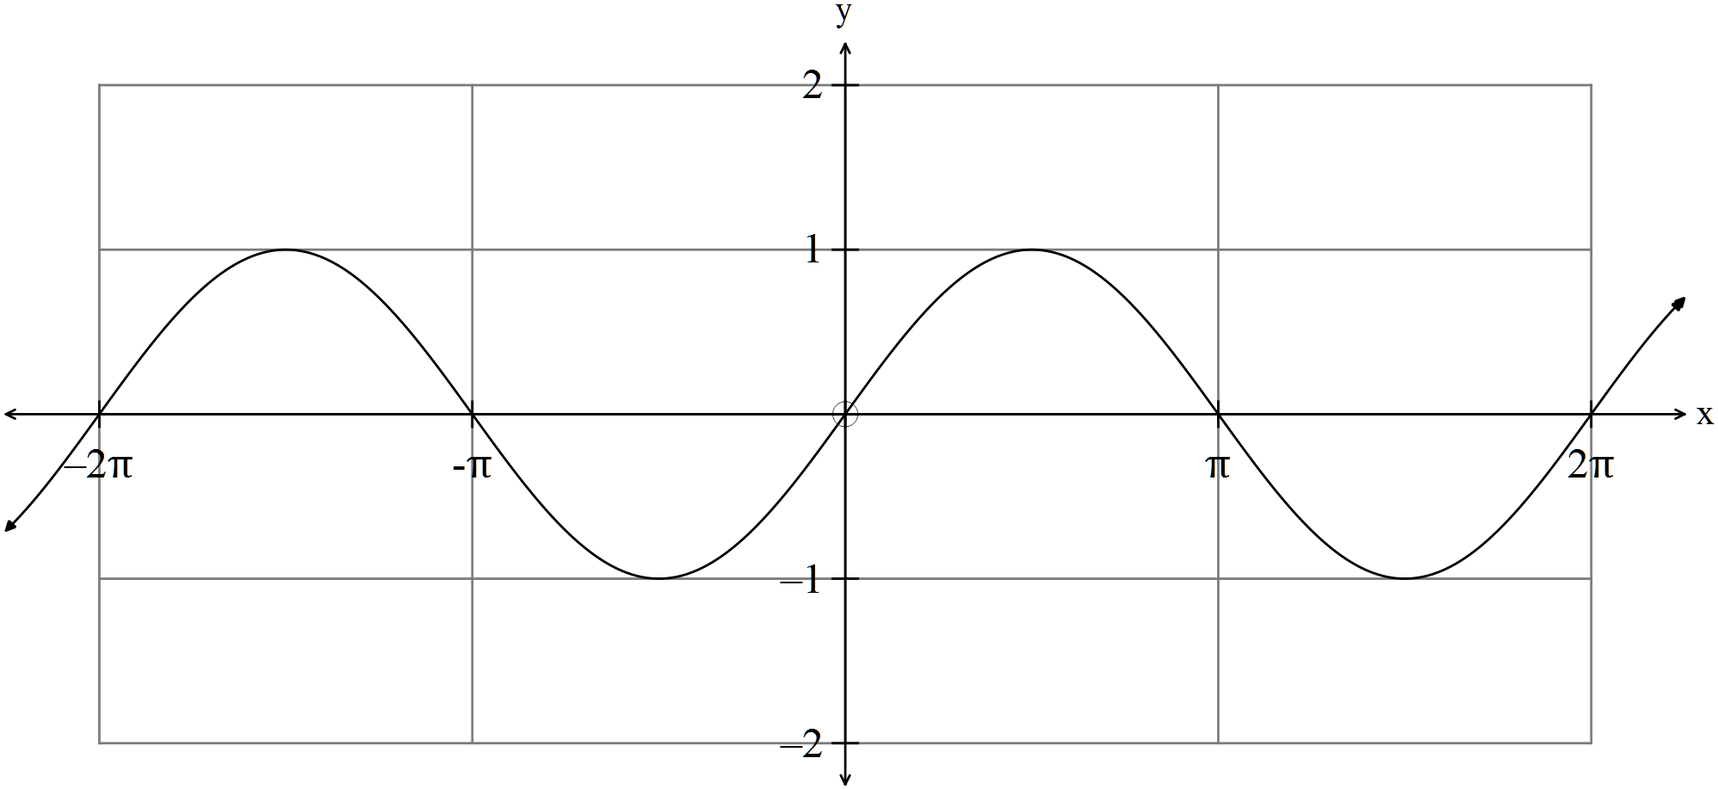

**Question 5 (4 marks)**

Determine  (4)

**Question 6 (5 marks)**

The production of a chemical in a laboratory can be modelled by the differential equation , where  kg is the total mass of the chemical produced after  hours.

Given that , determine an exact value for the total mass of substance produced after three hours.

Question 7 (4 marks)

Given the vector equation of a plane is



(a) Show that the point  belongs to the plane. (2)

The Cartesian equation of the plane is 

(b) Find the equation of a line that is perpendicular to the plane and contains

the point  (2)

Question 8 (8 marks)

A minor sector of angle  is removed from a circular piece of paper of radius . The two straight edges of the remaining major sector are pulled together to form a right circular cone, with a slant height of .



(a) Show that the volume of the cone is given by . (3)

(b) Find the value of  which maximises the volume of cone. (5)

End of Questions

Additional working space

Question number: _________